Inclined-Surface Wedge

Definition
# Source: AI Source: Provided by: [Data Path: Persons Table -> ID Column: 1, Name_En Column: Motasem Essam] -> From: [ChatGPT] on [7/25/2026]
An Inclined-Surface Wedge is a three-dimensional wedge-shaped solid characterized by an upper surface that slopes at an angle relative to its base.
Its height changes along at least one direction, creating an inclined face. Depending on its construction, the solid may have triangular, trapezoidal, rectangular, or other polygonal faces.
It is commonly represented by a block with a flat bottom and a sloping top surface.
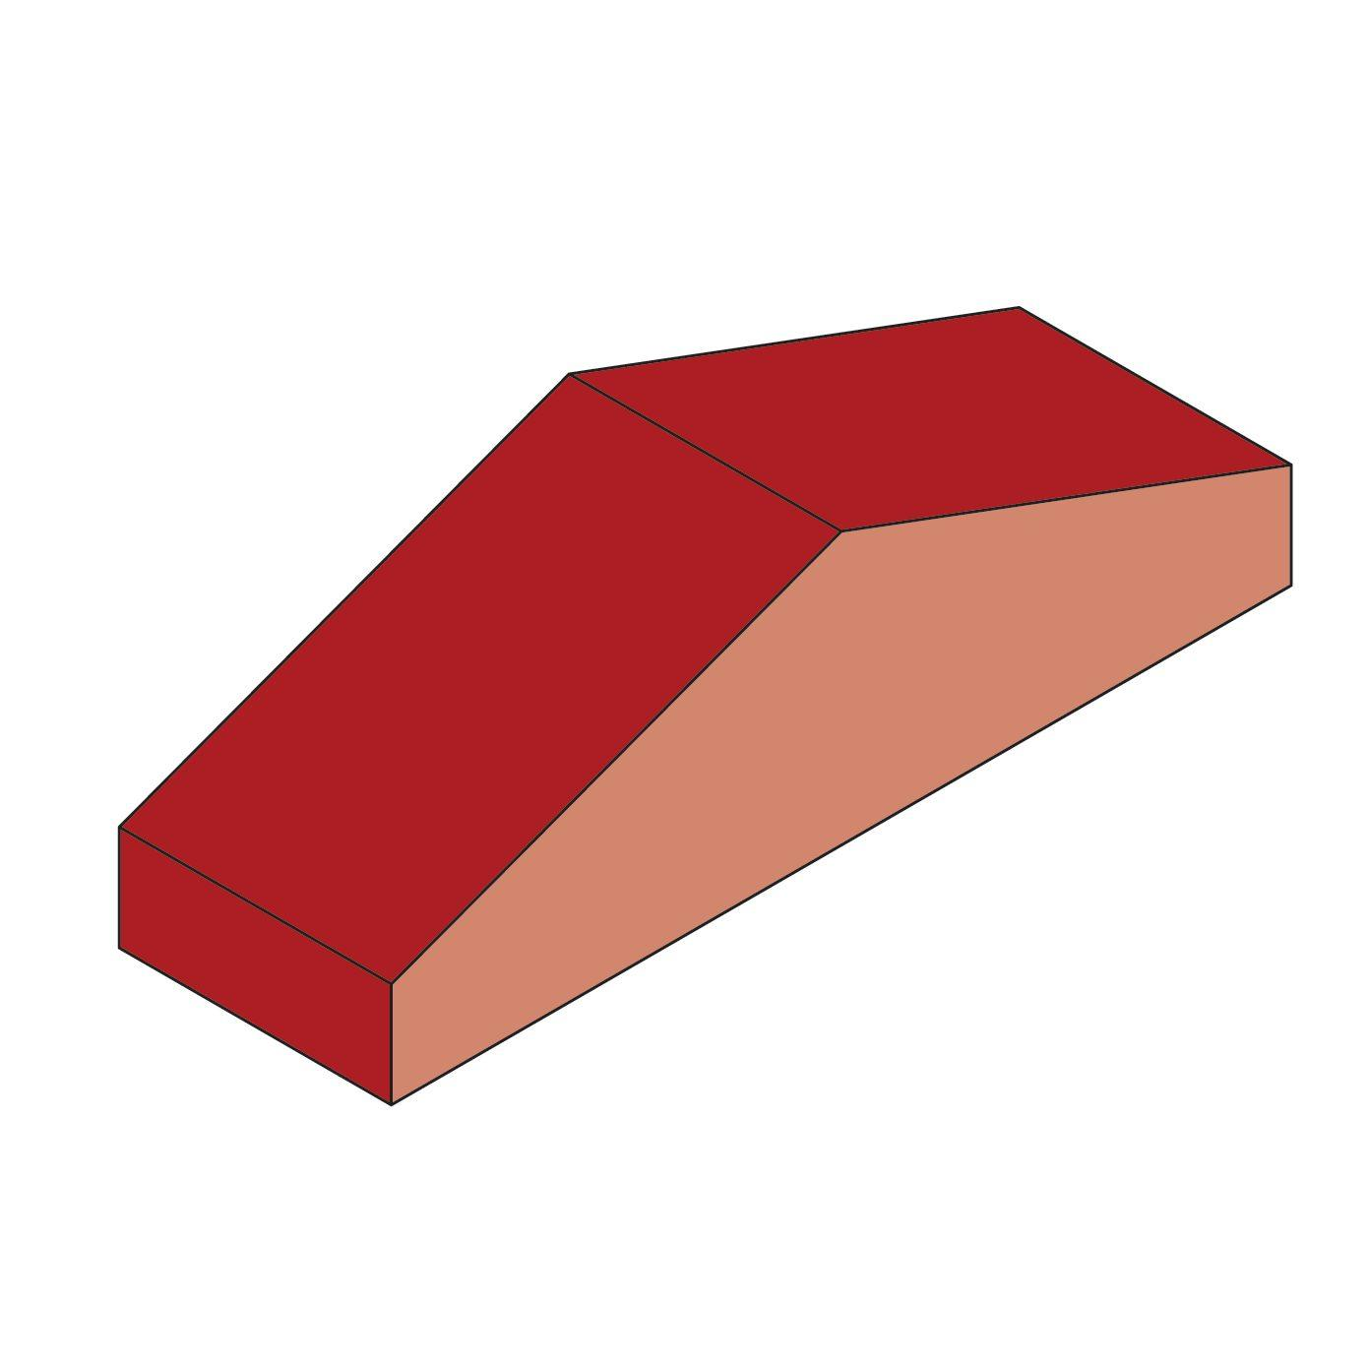
<caption>Inclined-surface wedge – a solid with a flat base and a sloping upper face.</caption>
Terminology note: “Inclined-surface wedge” is a descriptive name rather than a universally standardized polyhedron classification. The defining feature in this topic is the inclined face. The exact number and shape of its other faces depend on how the wedge is constructed.

Simple Definition
# Source: AI Source: Provided by: [Data Path: Persons Table -> ID Column: 1, Name_En Column: Motasem Essam] -> From: [ChatGPT] on [7/25/2026]
An inclined-surface wedge is a three-dimensional solid with a flat base and at least one sloping surface. Its thickness or height changes along a direction, giving it a tapered or ramp-like shape.

Geometric Structure
# Source: AI Source: Provided by: [Data Path: Persons Table -> ID Column: 1, Name_En Column: Motasem Essam] -> From: [ChatGPT] on [7/25/2026]
The main components are:
- Base: The bottom face, often rectangular.
- Inclined surface: The sloping face connecting a lower region to a higher region.
- Side faces: The faces connecting the base to the inclined surface.
- End faces: The faces closing the two ends of the solid.
- Edges and vertices: The boundaries and corners where the faces meet.
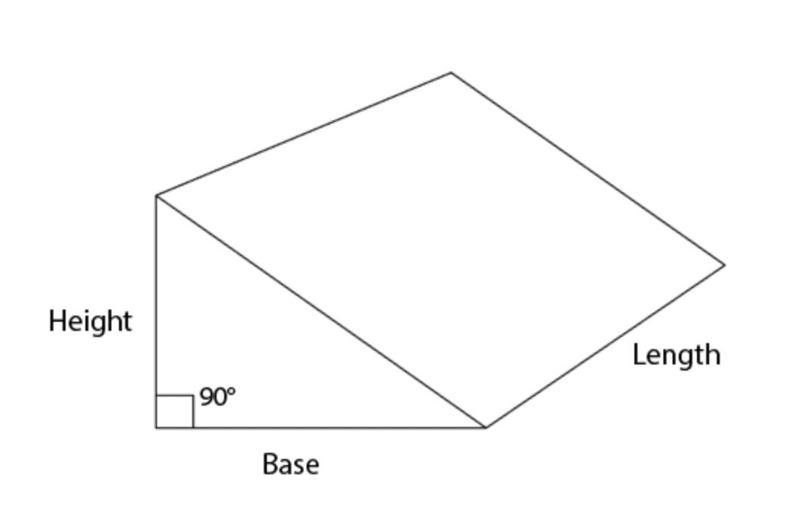

Face Structure
# Source: AI Source: Provided by: [Data Path: Persons Table -> ID Column: 1, Name_En Column: Motasem Essam] -> From: [ChatGPT] on [7/25/2026]
The number and shapes of the faces depend on the wedge's design. A simple wedge with a triangular-prism shape has 5 faces:
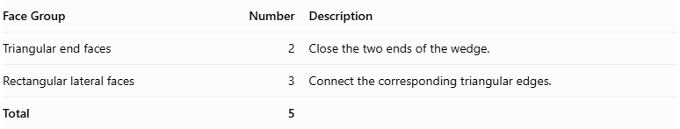
Face Group | Number | Description
Triangular end faces | 2 | Close the two ends of the wedge.
Rectangular lateral faces | 3 | Connect the corresponding triangular edges.
Total | 5
Other inclined-surface wedges may have additional faces, such as a short horizontal top face or an inclined face divided into several sections.
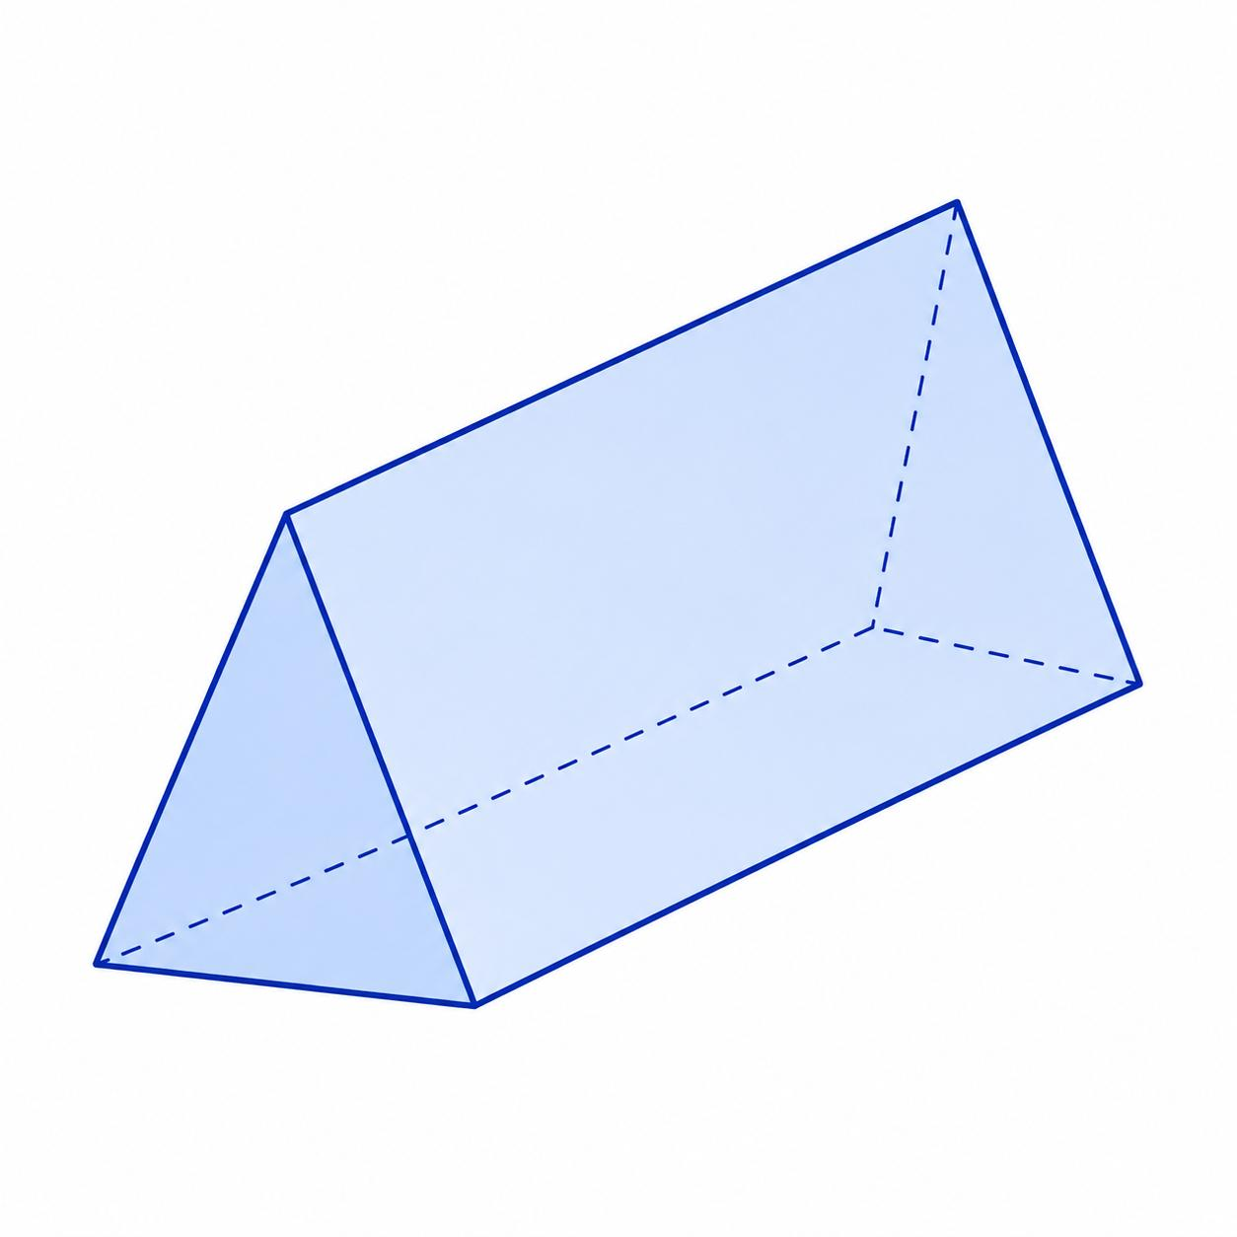

Edge Structure
# Source: AI Source: Provided by: [Data Path: Persons Table -> ID Column: 1, Name_En Column: Motasem Essam] -> From: [ChatGPT] on [7/25/2026]
For the simple triangular-prism wedge, there are 9 edges.
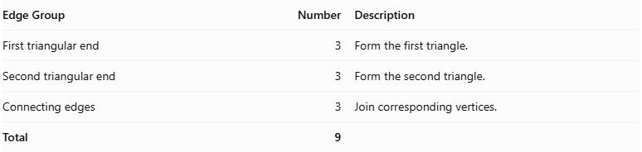
Edge Group | Number | Description
First triangular end | 3 | Form the first triangle.
Second triangular end | 3 | Form the second triangle.
Connecting edges | 3 | Join corresponding vertices.
Total | 9
More complex wedge designs may have additional edges.

Vertex Structure
# Source: AI Source: Provided by: [Data Path: Persons Table -> ID Column: 1, Name_En Column: Motasem Essam] -> From: [ChatGPT] on [7/25/2026]
For the simple triangular-prism wedge, there are 6 vertices.
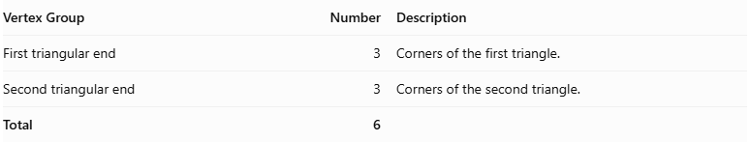
Vertex Group | Number | Description
First triangular end | 3 | Corners of the first triangle.
Second triangular end | 3 | Corners of the second triangle.
Total | 6

Mathematical Properties
# Source: AI Source: Provided by: [Data Path: Persons Table -> ID Column: 1, Name_En Column: Motasem Essam] -> From: [ChatGPT] on [7/25/2026]
For the simple triangular-prism form:
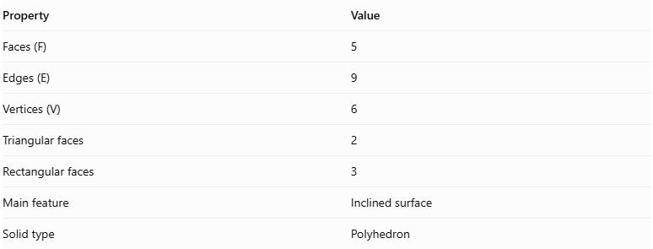
Property | Value
Faces (F) | 5
Edges (E) | 9
Vertices (V) | 6
Triangular faces | 2
Rectangular faces | 3
Main feature | Inclined surface
Solid type | Polyhedron
It satisfies Euler's polyhedron formula:
$$V-E+F=2$$
$$6-9+5=2$$
These counts apply to the simple triangular-prism form, not every possible inclined-surface wedge.

Surface Area
# Source: AI Source: Provided by: [Data Path: Persons Table -> ID Column: 1, Name_En Column: Motasem Essam] -> From: [ChatGPT] on [7/25/2026]
For a simple triangular-prism wedge, the total surface area is the sum of its two triangular ends and three rectangular lateral faces.
$$S=2A_{t}+A_{1}+A_{2}+A_{3}$$
If the triangular cross-section has perpendicular sides $h$ and $d$, hypotenuse $c$, and the wedge length is $L$:
$$A_{t}=\frac{1}{2}hd$$
Therefore:
$$\boxed{S=hd+L(h+d+c)}$$
Where:
$$c=\sqrt{h^{2}+d^{2}}$$

Volume
# Source: AI Source: Provided by: [Data Path: Persons Table -> ID Column: 1, Name_En Column: Motasem Essam] -> From: [ChatGPT] on [7/25/2026]
For a wedge with a triangular cross-section extending uniformly along its length:
$$V=A_{t}L$$
Since:
$$A_{t}=\frac{1}{2}hd$$
The volume is:
$$\boxed{V=\frac{1}{2}hdL}$$
Where:
- $h$ = height of the triangular cross-section.
- $d$ = horizontal depth of the triangular cross-section.
- $L$ = length of the wedge.
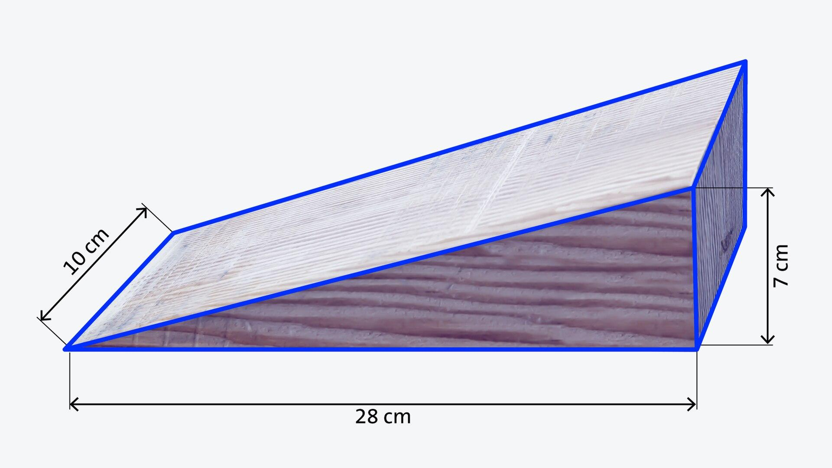

Inclination and Slope
# Source: AI Source: Provided by: [Data Path: Persons Table -> ID Column: 1, Name_En Column: Motasem Essam] -> From: [ChatGPT] on [7/25/2026]
The inclined surface forms an angle with the horizontal base.
For a simple wedge with a straight sloping surface:
$$\boxed{tanθ=\frac{h}{d}}$$
Therefore:
$$\boxed{θ=\tan^{-1}\left(\frac{h}{d}\right)}$$
Where:
- $θ$ = inclination angle.
- $h$ = vertical height.
- $d$ = horizontal distance.
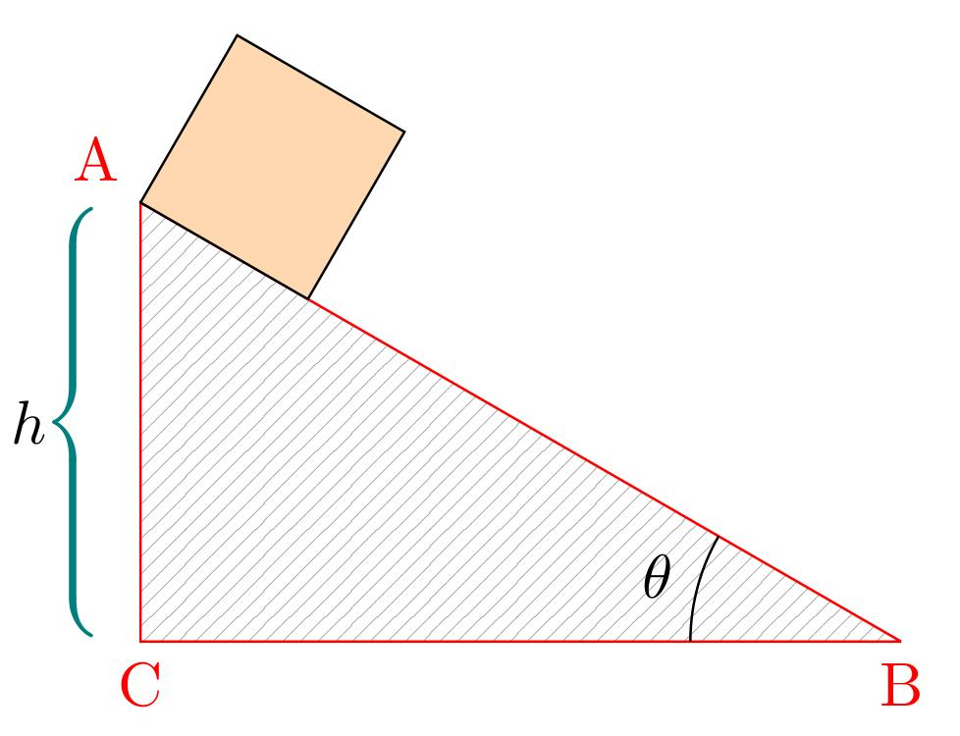

Relationship to Other Solids
# Source: AI Source: Provided by: [Data Path: Persons Table -> ID Column: 1, Name_En Column: Motasem Essam] -> From: [ChatGPT] on [7/25/2026]
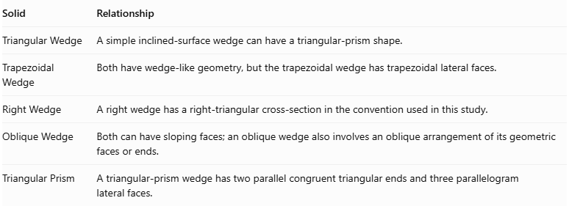
Solid | Relationship
Triangular Wedge | A simple inclined-surface wedge can have a triangular-prism shape.
Trapezoidal Wedge | Both have wedge-like geometry, but the trapezoidal wedge has trapezoidal lateral faces.
Right Wedge | A right wedge has a right-triangular cross-section in the convention used in this study.
Oblique Wedge | Both can have sloping faces; an oblique wedge also involves an oblique arrangement of its geometric faces or ends.
Triangular Prism | A triangular-prism wedge has two parallel congruent triangular ends and three parallelogram lateral faces.
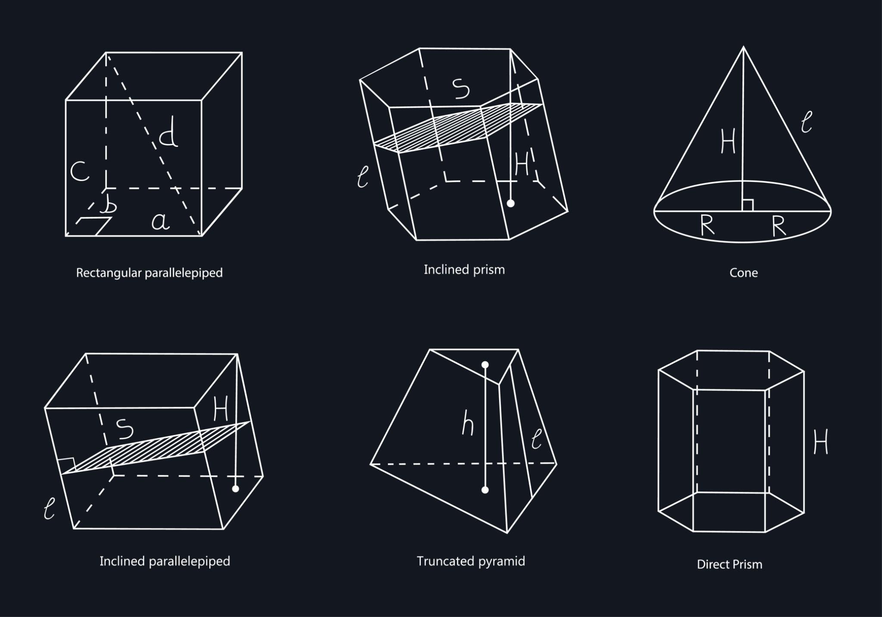

Worked Examples

Example 1: Calculate the Volume
# Source: AI Source: Provided by: [Data Path: Persons Table -> ID Column: 1, Name_En Column: Motasem Essam] -> From: [ChatGPT] on [7/25/2026]
Given:
- Height $h=6\text{ cm}$
- Horizontal depth $d=8\text{ cm}$
- Length $L=10\text{ cm}$
Using:
$$V=\frac{1}{2}hdL$$
Substituting:
$$V=\frac{1}{2}(6)(8)(10)$$
$$V=240$$
$$\boxed{V=240{\text{ cm}}^{3}}$$

Example 2: Calculate the Inclination Angle
# Source: AI Source: Provided by: [Data Path: Persons Table -> ID Column: 1, Name_En Column: Motasem Essam] -> From: [ChatGPT] on [7/25/2026]
Given:
- Height $h=6\text{ cm}$
- Horizontal distance $d=8\text{ cm}$
Using:
$$tanθ=\frac{h}{d}$$
$$tanθ=\frac{6}{8}=0.75$$
$$θ=\tan^{-1}(0.75)$$
$$\boxed{θ≈{36.87}^{°}}$$

Constructing Inclined-Surface Wedge in Solid Geometry

Geometric Instruments Used
# Source: AI Source: Provided by: [Data Path: Persons Table -> ID Column: 1, Name_En Column: Motasem Essam] -> From: [ChatGPT] on [7/25/2026]
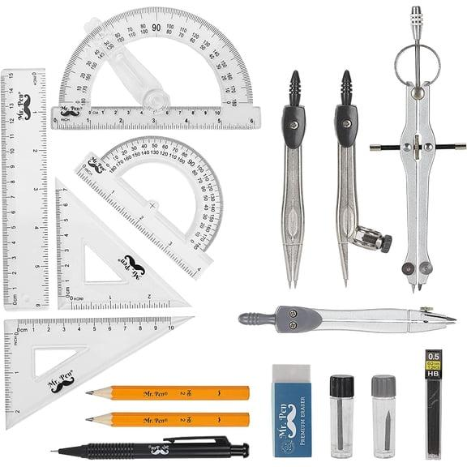
- Ruler: Drawing straight edges.
- Compass: Drawing arcs and transferring distances.
- Protractor: Measuring the inclination angle.
- Set square: Constructing perpendicular and parallel lines.
- Pencil: Drawing construction lines.
- Eraser: Removing unnecessary construction marks.

Instrument-Based Construction Procedures

A. Constructing the Base
# Source: AI Source: Provided by: [Data Path: Persons Table -> ID Column: 1, Name_En Column: Motasem Essam] -> From: [ChatGPT] on [7/25/2026]
- Draw a rectangle using a ruler.
- Mark its four corners.
- Establish the required length and depth.
- Complete the base outline.

B. Constructing the Inclined Surface
# Source: AI Source: Provided by: [Data Path: Persons Table -> ID Column: 1, Name_En Column: Motasem Essam] -> From: [ChatGPT] on [7/25/2026]
- Identify the starting point of the inclined surface.
- Mark the required vertical height.
- Use a protractor to establish the inclination angle.
- Draw the sloping edge connecting the lower and upper positions.

C. Constructing the Side Faces
# Source: AI Source: Provided by: [Data Path: Persons Table -> ID Column: 1, Name_En Column: Motasem Essam] -> From: [ChatGPT] on [7/25/2026]
- Draw the two end profiles.
- Connect their corresponding vertices.
- Construct the lateral faces.
- Ensure that the inclined surface connects correctly to the side faces.

D. Completing the Inclined-Surface Wedge
# Source: AI Source: Provided by: [Data Path: Persons Table -> ID Column: 1, Name_En Column: Motasem Essam] -> From: [ChatGPT] on [7/25/2026]
- Check the base and inclined surface.
- Verify the required dimensions and angle.
- Darken the visible edges.
- Draw hidden edges using dashed lines when necessary.
- Remove unnecessary construction marks.
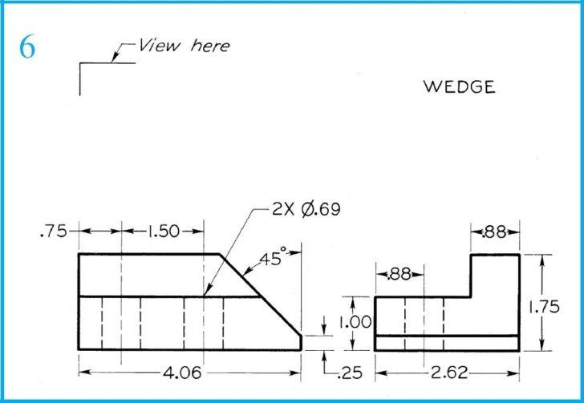

Key Points
# Source: AI Source: Provided by: [Data Path: Persons Table -> ID Column: 1, Name_En Column: Motasem Essam] -> From: [ChatGPT] on [7/25/2026]
- An inclined-surface wedge is a three-dimensional wedge-shaped solid.
- It has at least one sloping surface.
- Its height or thickness changes along a direction.
- Its base is often rectangular.
- Its faces may be triangular, rectangular, trapezoidal, or other polygons.
- Its surface area is the sum of all its external face areas.
- Its volume depends on its cross-section and dimensions.
- Its inclination angle can be calculated using the tangent ratio.

Conclusion
# Source: AI Source: Provided by: [Data Path: Persons Table -> ID Column: 1, Name_En Column: Motasem Essam] -> From: [ChatGPT] on [7/25/2026]
An Inclined-Surface Wedge is a three-dimensional solid characterized by a sloping surface connecting different heights above its base. Its geometry may vary depending on its construction, but its defining feature is the inclined face that gives the solid its wedge-like appearance.

Image and reference sources
# Source: AI Source: Provided by: [Data Path: Persons Table -> ID Column: 1, Name_En Column: Motasem Essam] -> From: [ChatGPT] on [7/25/2026]
- ANSYS – Solid Wedge — describes wedge solids as boxes with inclined faces.
- Wedge – Wolfram MathWorld — mathematical definitions and wedge geometry.
- Wedge Shape – Kinetic USA — flat-bottomed ramp with an inclined face.
- Engineering Graphics – Inclined Surfaces — technical drawing and representation of inclined surfaces.

